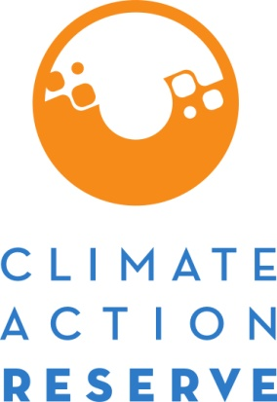

**Request for Project Verification Deadline Extension**

February 2025

The Climate Action Reserve (Reserve) may grant an extension to a project’s verification deadline upon submission of this form. For initial and subsequent reporting period verification deadlines, please refer to the specific protocol. All verifications must be submitted within 12 months of the end of the verification reporting period. No extension request will be granted unless the project has commenced verification and has undergone a site visit for the reporting period (or has submitted data to the verification body in the event of a desk review verification) and all outstanding invoices for the project and account holder have been paid. The account holder must also submit a monitoring report along with the form. The following extensions may be granted:

* All sequestration projects may be granted a 12-month extension.
* All non-sequestration projects may be granted a six-month extension.

Only with explicit, written approval of the request may an account holder submit a project for registration after the verification deadline has passed. The Reserve retains the right to (1) reject any Request for Project Verification Deadline Extension that does not comply with these requirements, (2) request further documentation, and/or (3) impose additional constraints. If the Reserve accepts this extension request, a letter stating the new project verification deadline will be sent to the account holder and will be made publicly available. A maximum of one extension may be granted per project. Extension requests must be received prior to the project’s verification deadline. If the extension for a subsequent reporting period is denied or is approved and the new verification deadline is missed, the project must apply for a Zero-Credit Reporting Period. If the extension for an initial reporting period is denied or the new verification deadline is missed, the project must be resubmitted under the most current version of its associated protocol (refer to Section 3.5.4 of the Reserve’s Offset Program Manual for further requirements). Be advised that missing the verification deadline for initial verification reporting periods may impact the project’s eligibility under the protocol.

*Instructions*

1. Complete the Request for Project Verification Deadline Extension form and submit it using the project documents tab, selecting the document type “Request for Project Extension” from the dropdown menu.
2. The Reserve will complete its review of the form and requested documentation.

**Project Details**

Date of Request:

Account Holder:

Technical Consultant (if applicable):

Project ID Number (e.g. CAR100) or Cooperative/Aggregate ID Number:

Project Name:

Project Type:

Protocol Version Used:

Reporting Period (for which request applies to):       to

Form Completed By (name and email):

1. If reporting period is being verified with a site visit, has a site visit occurred?

Yes, Date(s):       No N/A

1. If reporting period is being verified with a desk review verification, has required project data and documentation been submitted to the verification body?

Yes, Date(s):       No N/A

1. Reason for Extension: provide a detailed description of any issues that are contributing to the delay in meeting the deadline.
2. Provide documentation to confirm a site visit for the project has occurred (e.g., List of Findings reflecting site visit activity, draft Verification Report, plane tickets, travel receipts, etc.) or – for desk review verifications and project types that do not require site visits - to confirm project documentation and data has been submitted (e.g., email correspondence, “Dropbox,” ftp, etc.).
3. Provide the monitoring report for the reporting period as an attachment, or part of this form.
4. Has this project received a verification extension previously? Previous extension determinations can be found in the Software, under Project Documents.

Yes       No       If yes, when